**LAB 01 : To become familiar with Mongo DB**

**LAB TASKS:**

**SECTION 1**

1. Perform Each and every task provided in the lab handout.
2. Lab tasks
3. Create Database and create collection of the data of your own choice and attach screenshot of every output. .
4. Use at least 5 collection functions of your own choice and attach screenshot of every output.
5. Use any five Aggregation Pipeline Operators on the data of your own choice and attach screenshot of every output.
6. Use any five aggregation pipeline stages on the data of your own choice and attach screenshot of every output.

1. Installation of Mongo Db and use its interface for creating database and collections.
2. Attach screenshots of your installed database and create 3 different databases of your own choice.

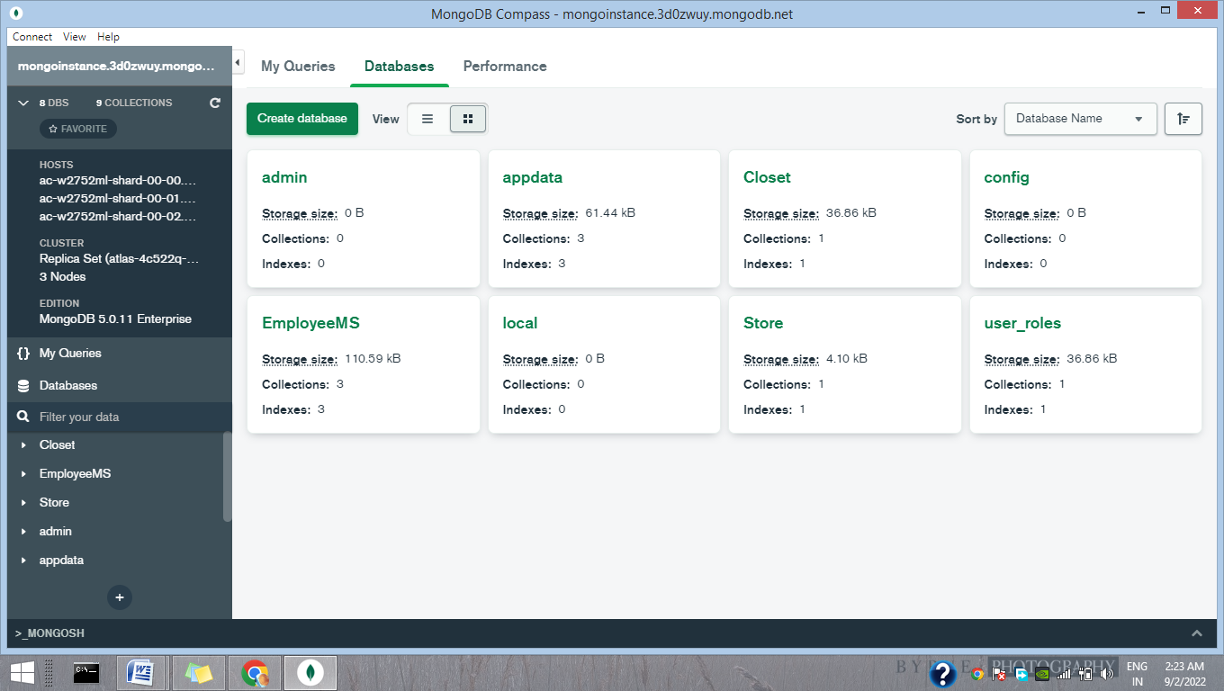

1. Populate those databases with minimum 15 documents using MongoDB GUI and each document should contain at least 6 key-value pairs. For example use Emp table data that you have used in db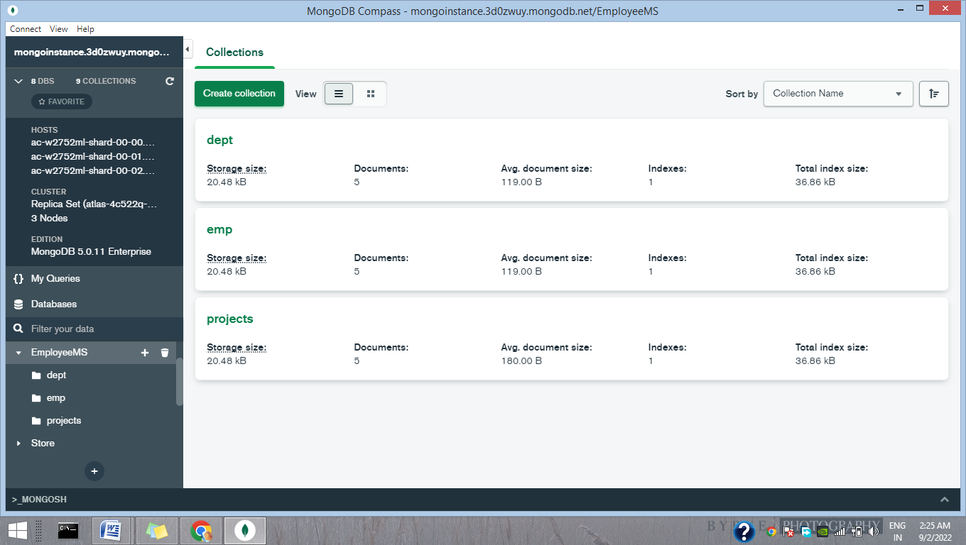

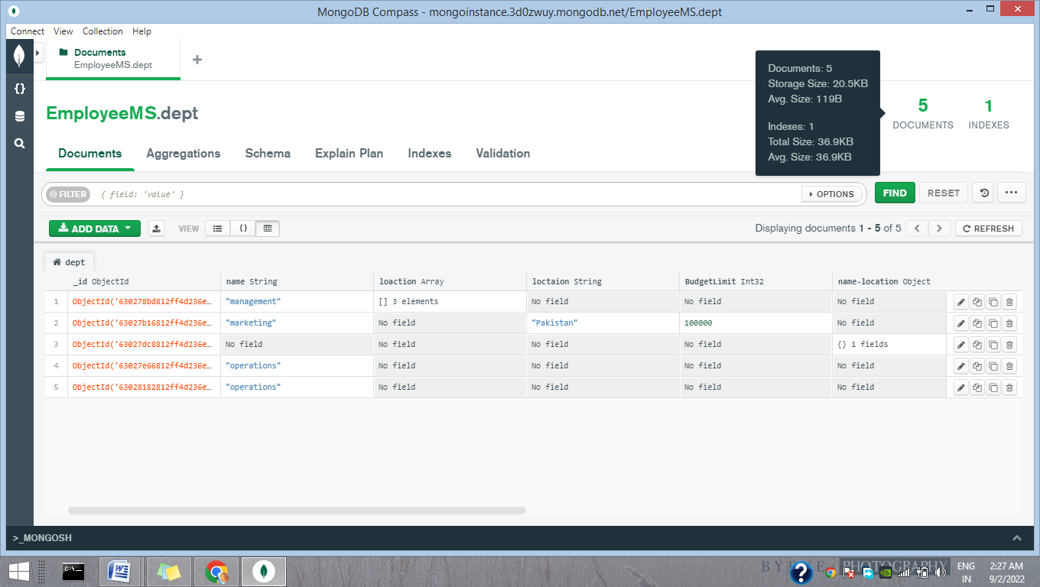continue

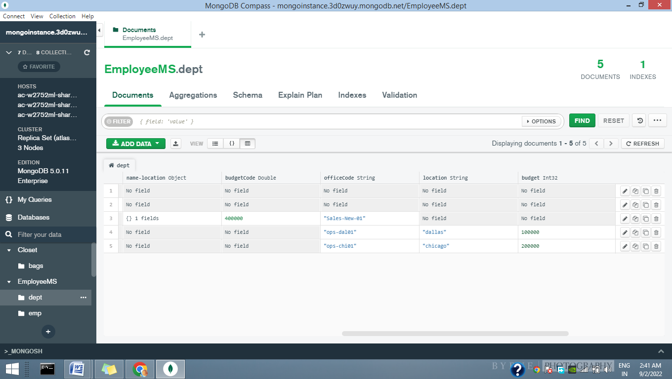

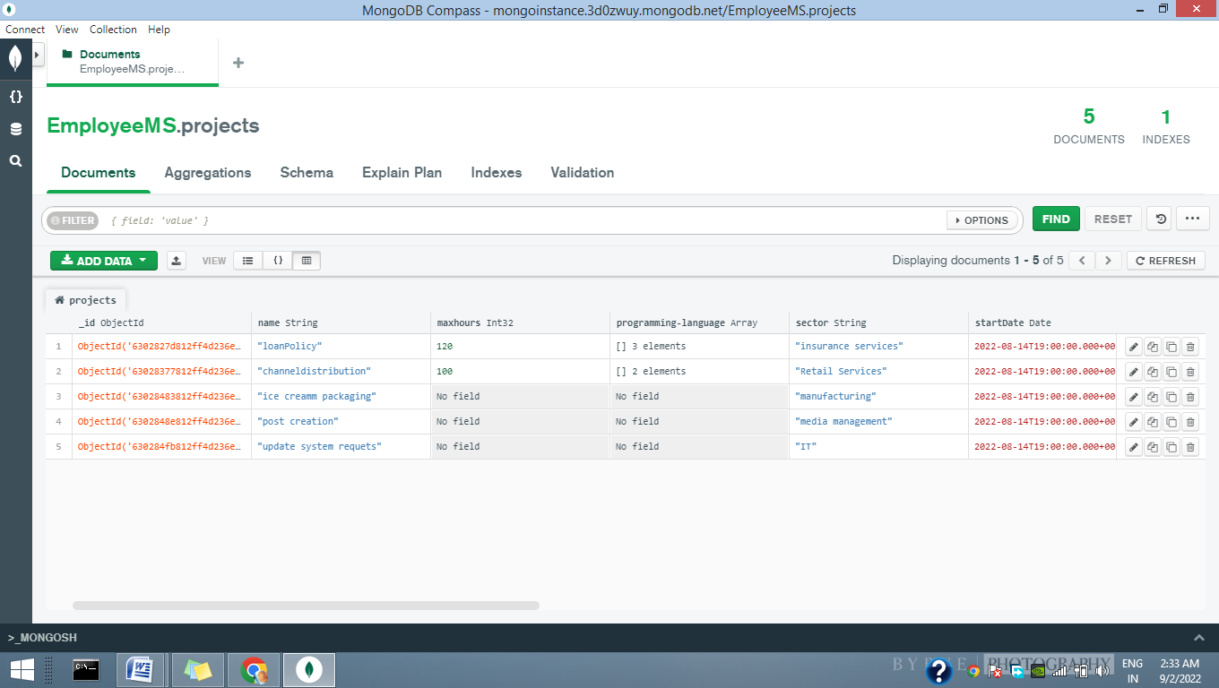continue

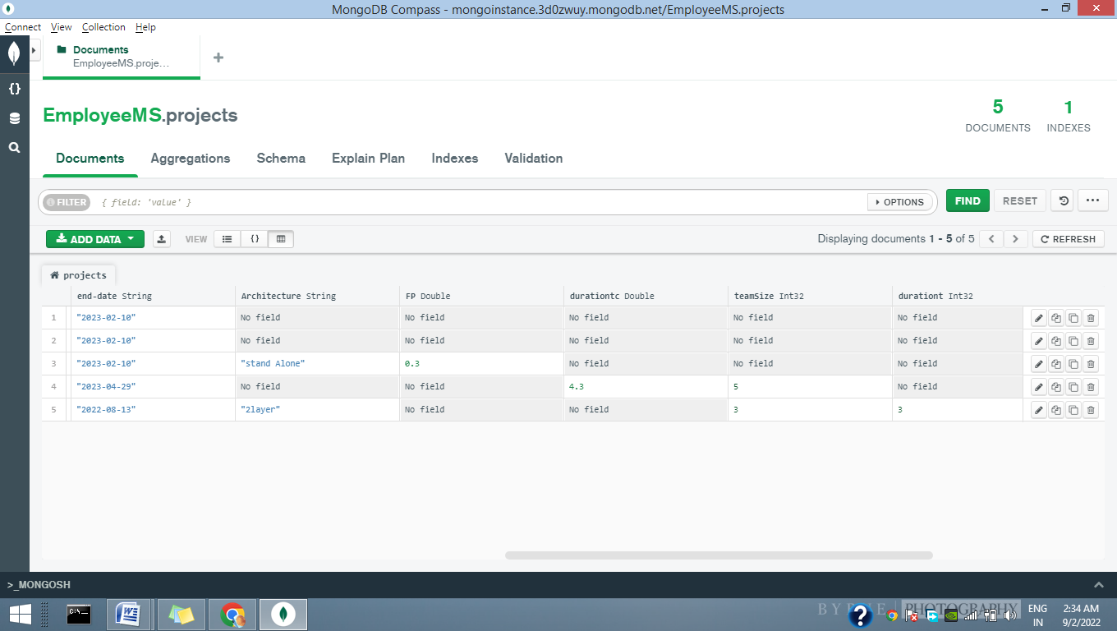

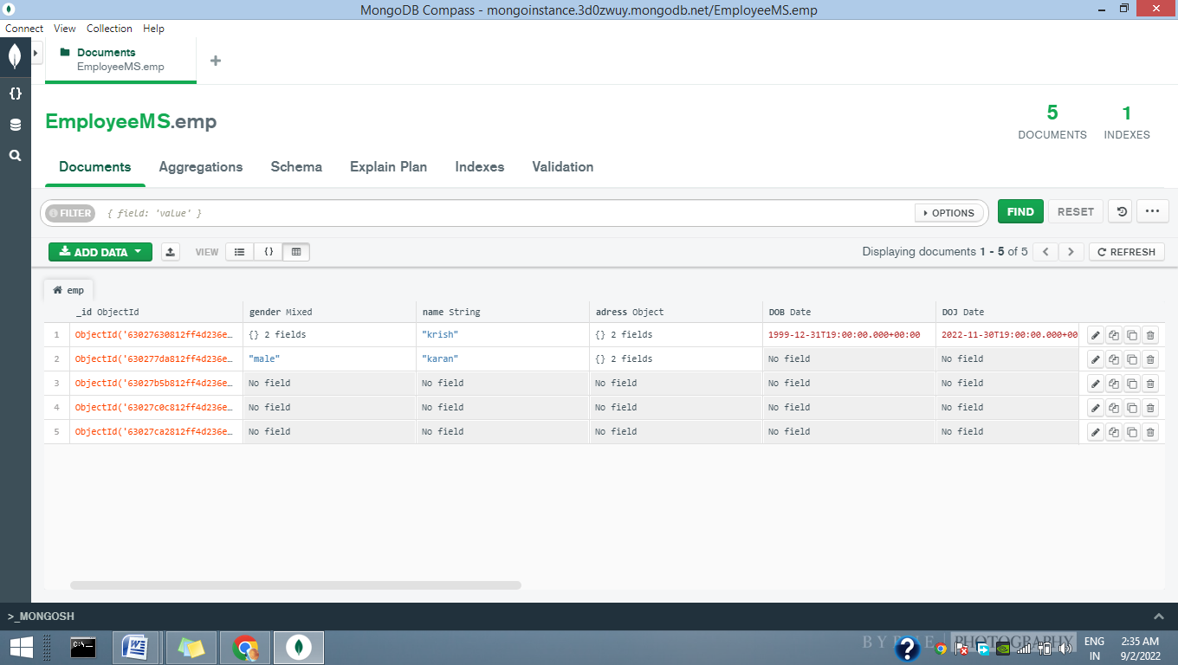continue

